Supplemental Material

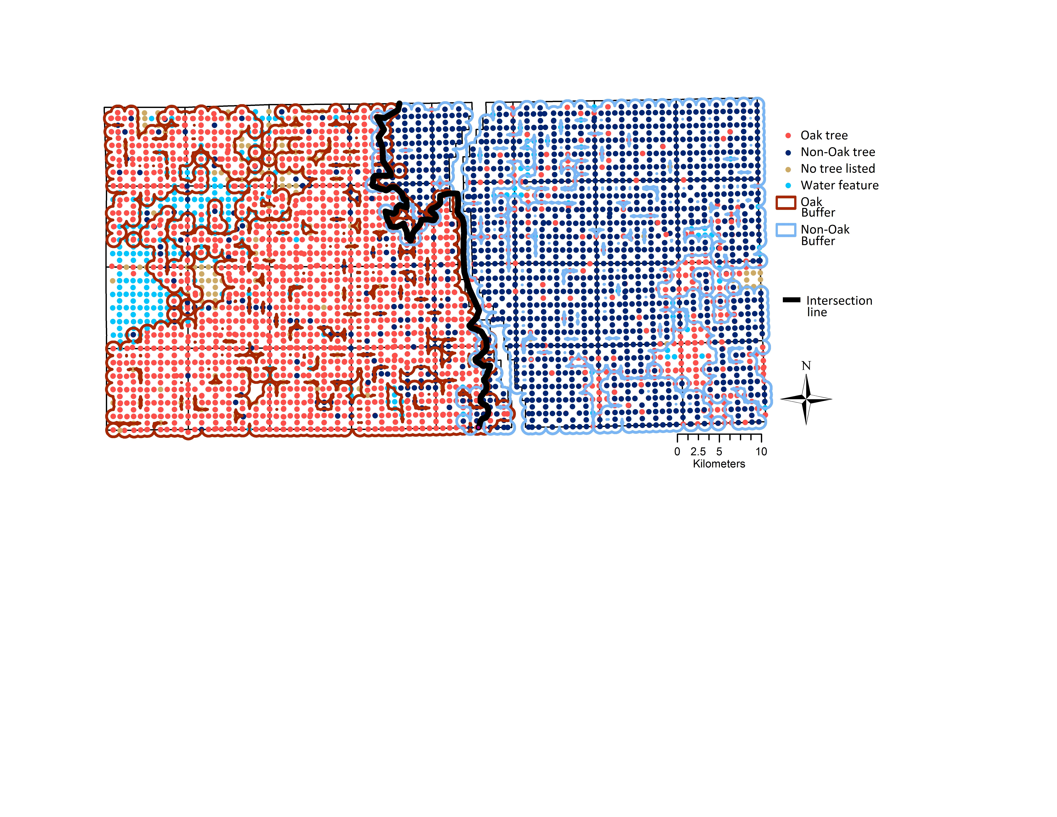

**Figure S1. ──Eastern and western vegetation types, delineated by overlapping buffers of oak and non-oak trees in ArcGIS.** Buffers draw in ArcGIS with radius r=0.5 mi, around spatially continuous oak (orange) and nonoak (blue) species. The black midline between the two buffers divides the study area into eastern (oak-dominated) and western (mixed forest) halves.

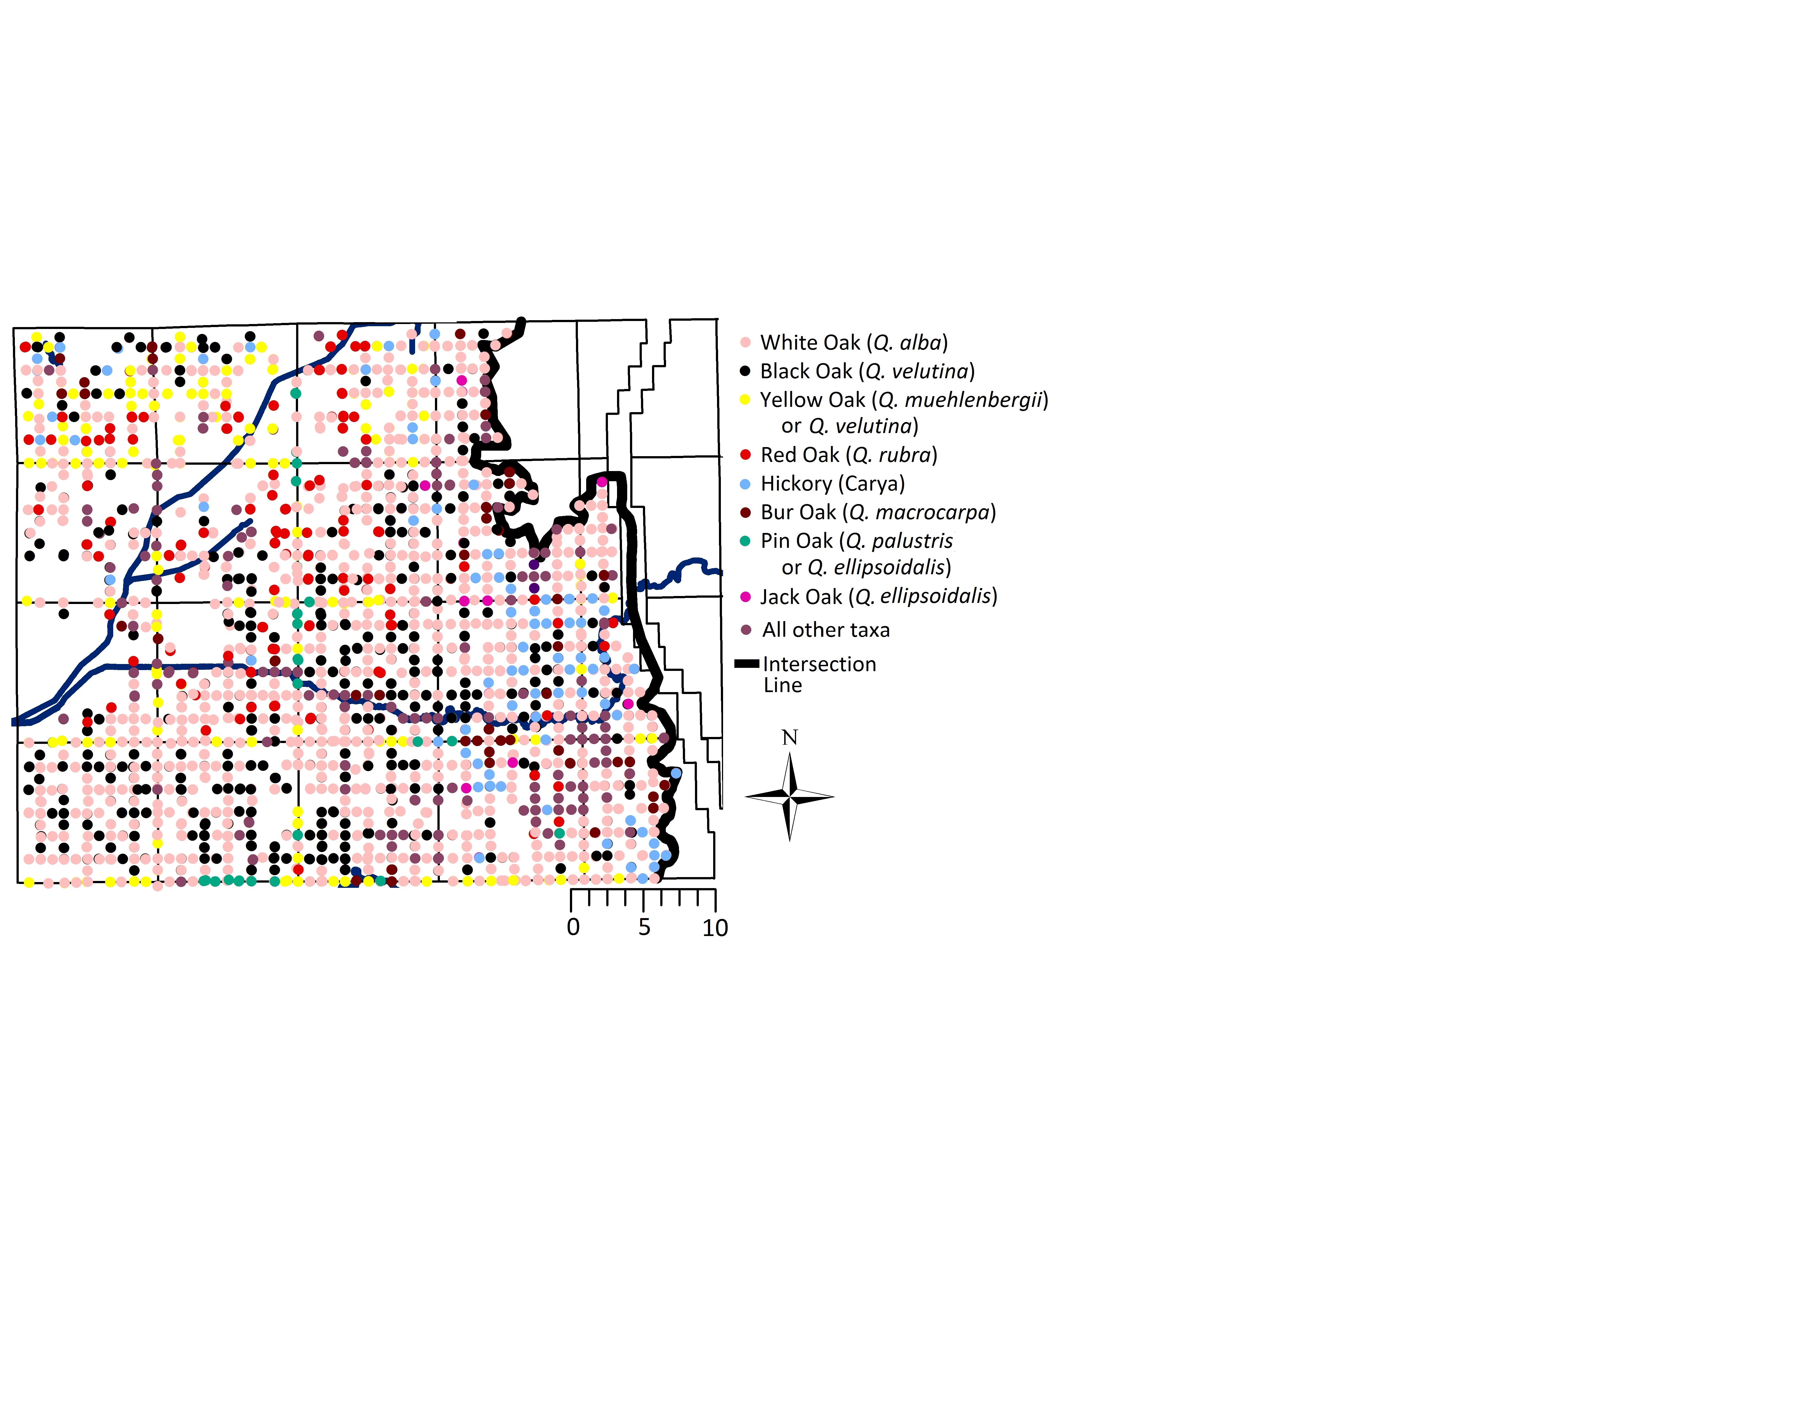

**Figure S2: Trees in western oak area further separated by species*.** Fire-tolerant black oak (black) and burr oak (orange) are evenly distributed within the western region. This indicates that tree species in the western side are not distributed in a way that suggests a gradient in tree ecological characteristics, and that it is appropriate to group the area as one association for comparative purposes.

*Because surveyors only recorded common names, there is some ambiguity about certain oak species. According to White (2005), yellow oak could be *Q. muehlenbergii* or *Q. velutina*, and pin oak can be *Q. palustris* or *Q. ellipsoidalis*. Jack oak is most likely *Q. ellipsoidalis* but surveyors also used the term jack oak to refer to a number of scrubby oak species (White 2005).

Table S1. Full list of east/west comparisons for environmental and modern descriptions.

|  |  |  |
| --- | --- | --- |
| **Variable short description** | **Long description** | **Source** |
| Temperature | 30-yr Normal Mean Temperature Annual in degrees C | PRISM Climate Group, Oregon State University, <http://prism.oregonstate.edu>. |
| Precipitation | 30-yr Normal Precipitation (in mm) | PRISM Climate Group |
| Elevation | National Elevation Dataset (10m resolution) | National Elevation Dataset http://nationalmap.gov/elevation.html |
| National Commodity Crop Productivity Index (all) | The map unit average National Commodity Crop Productivity Index values are provided for major earthy components. (Low index values indicate low productivity, and high index values indicate high productivity.) Table column names begin with &ldquo;nccpi.&rdquo; NCCPI values are included for corn/soybeans, small grains, and cotton crops. Of these crops, the highest overall NCCPI value is also identified. Earthy components are those soil series or higher level taxa components that can support crop growth. Major components are those soil components for which the MAJCOMPFLAG is &ldquo;Yes&rdquo; in the SSURGO component table. A map unit percent composition for earthy major components is provided (Dobos, Sinclair, Jr., and Robotham, 2012). | SSURGO valu1 table. Soil Survey Group, Natural Resource Conservation Service, United States Department of Agriculture. |
| Drainage Class- dominant condition | The natural drainage condition of the soil refers to the frequency and duration of wet periods. This column displays the dominant drainage class for the map unit, based on composition percentage of each map unit component. | SSURGO muaggatt table |
| Modern land use | 30 m grid showing 2006 land cover data in Indiana. There are 15 categories of land use. | Fry, J., G. Xian, S. Jin, J. Dewitz, C. Homer, L. Yang, C. Barnes, N. Herold, and J. Wickham. 2011. Completion of the 2006 National Land Cover Database for the Conterminous United States. *PE&RS*, **77**:858-864. |
| Sand content (sandtotal_r) | Mineral particles 0.05mm to 2.0mm in equivalent diameter as a weight percentage of the less than 2 mm fraction. | SSURGO chorizon table |
| Silt content (silttotal_r) | Mineral particles 0.002 to 0.05mm in equivalent diameter as a weight percentage of the less than 2.0mm fraction. | SSURGO chorizon table |
| Clay content (claytotal_r) | Mineral particles less than 0.002mm in equivalent diameter as a weight percentage of the less than 2.0mm fraction. | SSURGO chorizon table |
| Organic matter (om_r) | Percent representative soil organic matter.  The amount by weight of decomposed plant and animal residue expressed as a weight percentage of the less than 2 mm soil material. | SSURGO chorizon table |
| Saturated Hydraulic Conductivity (ksat_r) | The amount of water that would move vertically through a unit area of saturated soil in unit time under unit hydraulic gradient. | SSURGO chorizon table |
| Available water capacity (awc_r) | The amount of water that an increment of soil depth, inclusive of fragments, can store that is available to plants. AWC is expressed as a volume fraction, and is commonly estimated as the difference between the water contents at 1/10 or 1/3 bar (field capacity) and 15 bars (permanent wilting point) tension and adjusted for salinity, and fragments. | SSURGO chorizon table |
| Erodibility factor (kwfact) | An erodibility factor which quantifies the susceptibility of soil particles to detachment and movement by water. This factor is adjusted for theeffect of rock fragments. | SSURGO chorizon table |

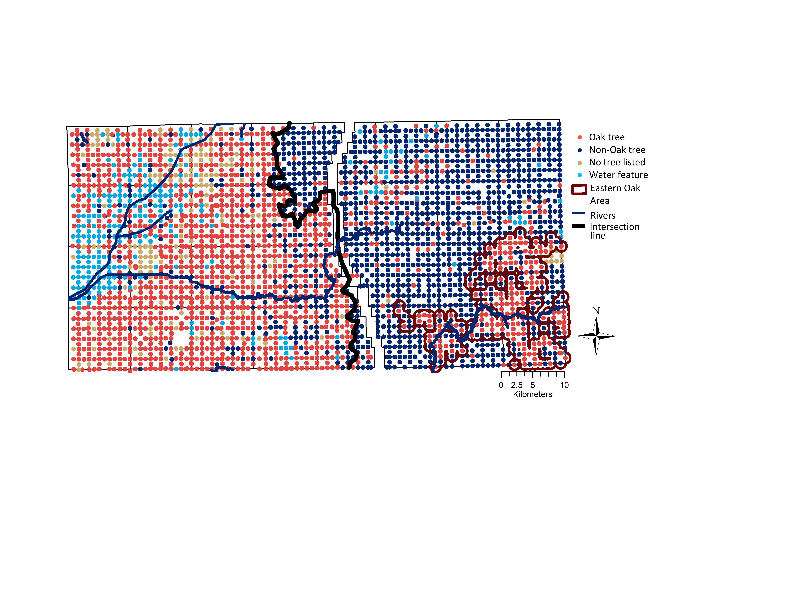

**Figure S3: Eastern oak “island”.** Cluster of oak dominance within the eastern region, quantified with the same ArcGIS buffer tool with radius r = 0.5 mi. This area includes 617 trees and 293 survey corners which were used to compare forest structure and environmental characteristics.

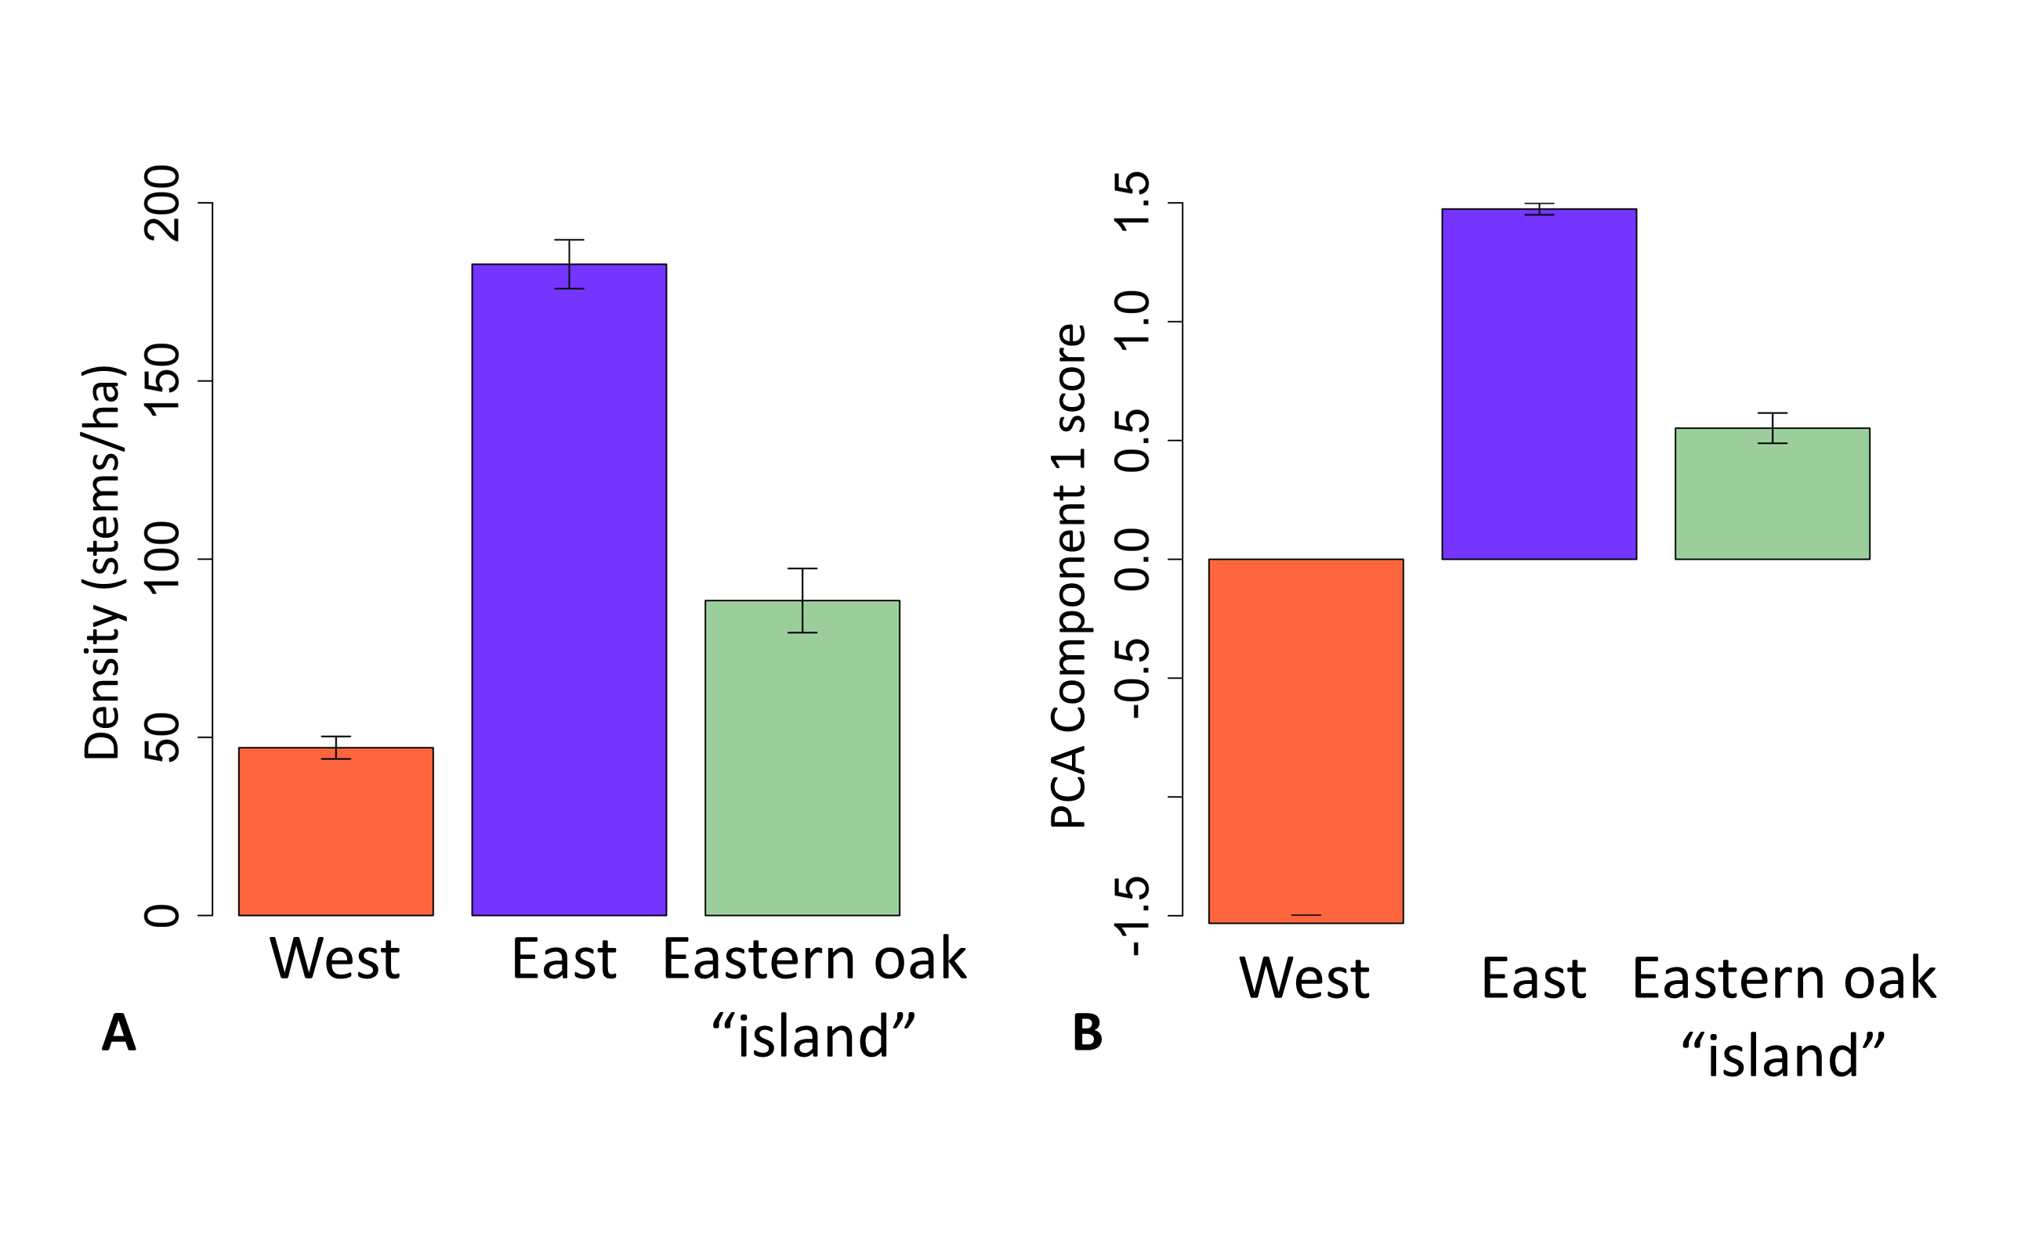**Figure S4: Structure and environment of eastern oak “island”.** (**A**) Stem density and (**B**) first principal component score of the small eastern oak area, compared to the two main vegetation areas. Error bars represent standard error. Eastern oak region has intermediate density and environment, but more closely resembles the western vegetation structure and the eastern environment.

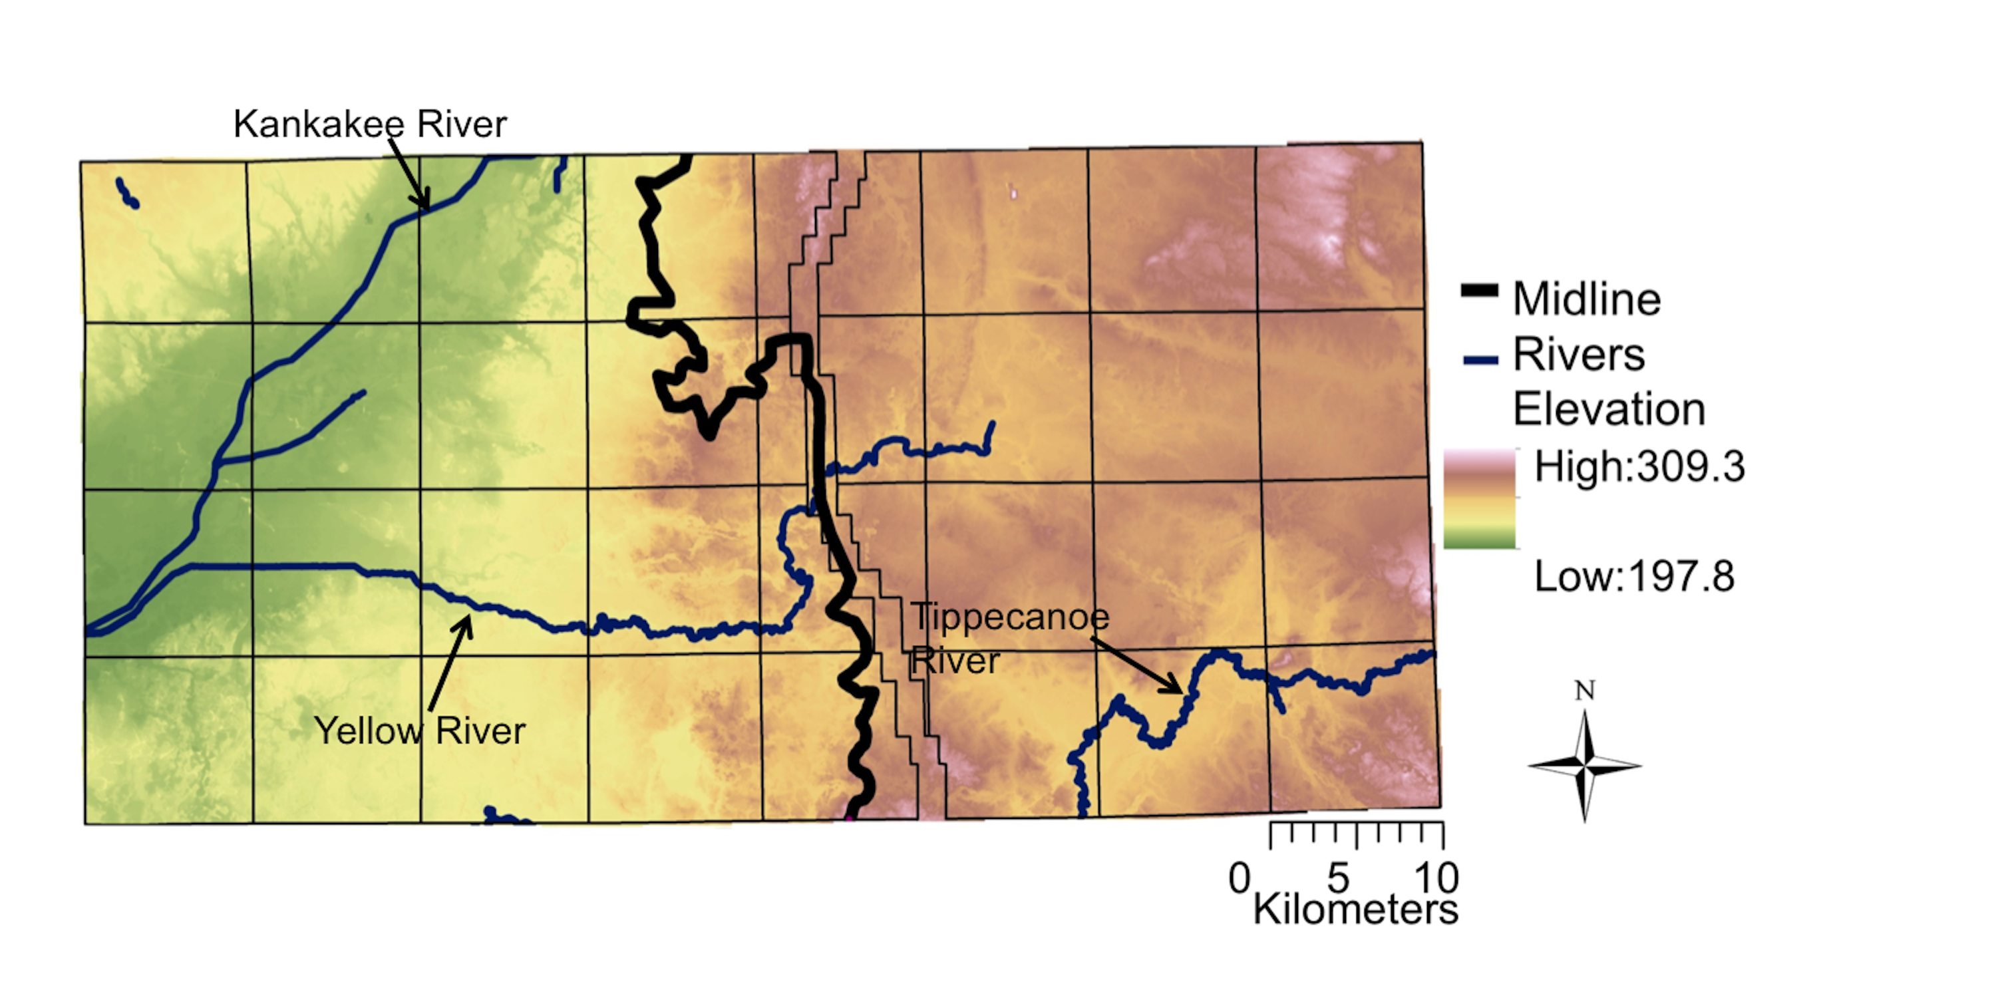Figure S5. Elevation (m) within watershed. Elevation dropoff tracks vegetation division (black line). There is a lower elevation around the Kankakee River in the west, and a slight decrease in elevation around the Tippecanoe River in the southeast. The black grid is the map of PLS survey townships, bisected by the Michigan Road Lands.

Table S2. Loadings of factors into the first and second principal component axes.

|  |  |  |
| --- | --- | --- |
|  | PC1 | PC2 |
| Temperature | 0.233 | -0.554 |
| Precipitation | 0.016 | -0.259 |
| Elevation | 0.342 | -0.396 |
| Sand % | -0.357 | 0.100 |
| Silt % | 0.420 | 0.190 |
| Clay % | 0.428 | 0.145 |
| Organic matter | 0.205 | 0.606 |
| Hydraulic conductivity (ksat) | -0.390 | 0.074 |
| Available water content (awc) | 0.384 | 0.175 |